buscamos las versiones disponibles
apt search inadyn

instalamos
apt install inadyn

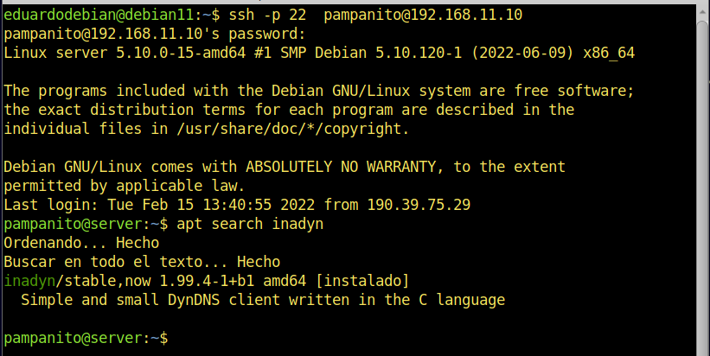
ubicamos el puerto como se llama el puerto
ip link show

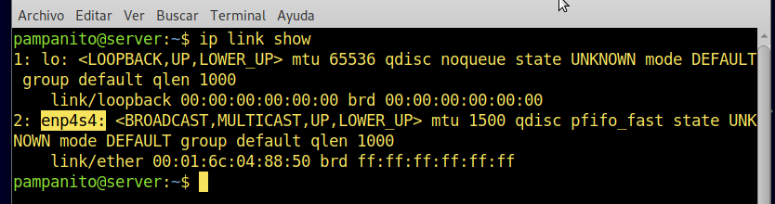
abre el manual
man inadyn

configurar inadyn

nano /etc/inadyn.conf

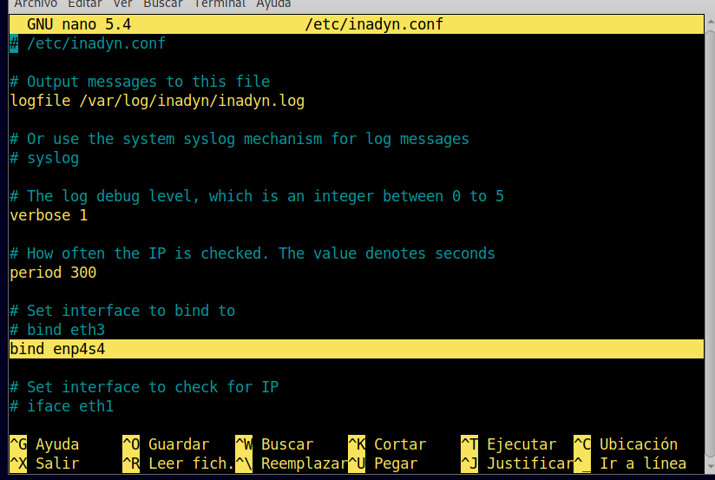
# Set interface to bind to
# bind eth3
bind enp…

# Set interface to bind to
# bind eth3
bind enp4s4

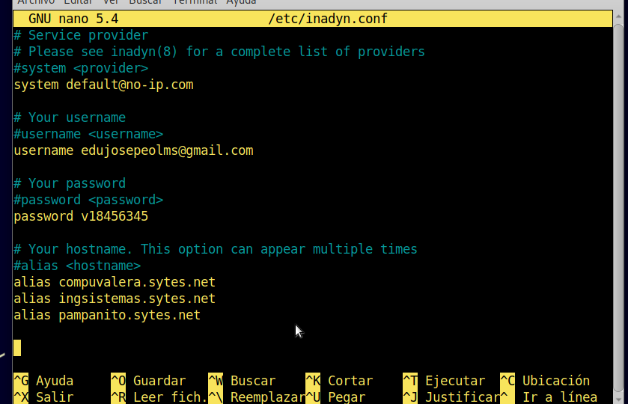
# Service provider
# Please see inadyn(8) for a complete list of providers
#system <provider>
system default@no-ip.com

# Your username
#username <username>
username edujosepeolms@gmail.com

# Your password
#password <password>
password v18456345

# Your hostname. This option can appear multiple times
#alias <hostname>
alias compuvalera.sytes.net
alias ingsistemas.sytes.net
alias pampanito.sytes.net
7a4j1vq
compuvalera.sytes
7a4j1vq@ddnskey.com
UZubh24U1T4V

pampanito.sytes
vqkwgpv@ddnskey.com
Pv7oB8tE1ssN

ingsistemas.sytes
hbr15e9@ddnskey.com
Y18rQTfpUcKE

all.ddnskey.com

noip-duc -g myhostname.ddns.net -u username -p password
noip-duc -g all.ddnskey.com -u 7a4j1vq7-p UZubh24U1T4V
noip-duc -g all.ddnskey.com --username 7a4j1vq --password UZubh24U1T4V
noip-duc -g all.ddnskey.com --username vqkwgpv --password Pv7oB8tE1ssN
noip-duc -g all.ddnskey.com --username hbr15e9 --password Y18rQTfpUcKE

7a4j1vq@ddnskey.com

crontab -e

agregar al final
@reboot /usr/sbin/inadyn

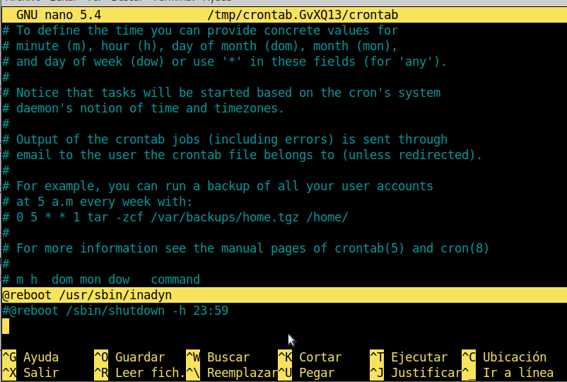
reboot

verificar
cat logfile /var/log/inadyn/inadyn.log

procedemos a editar
nano /etc/network/interfaces

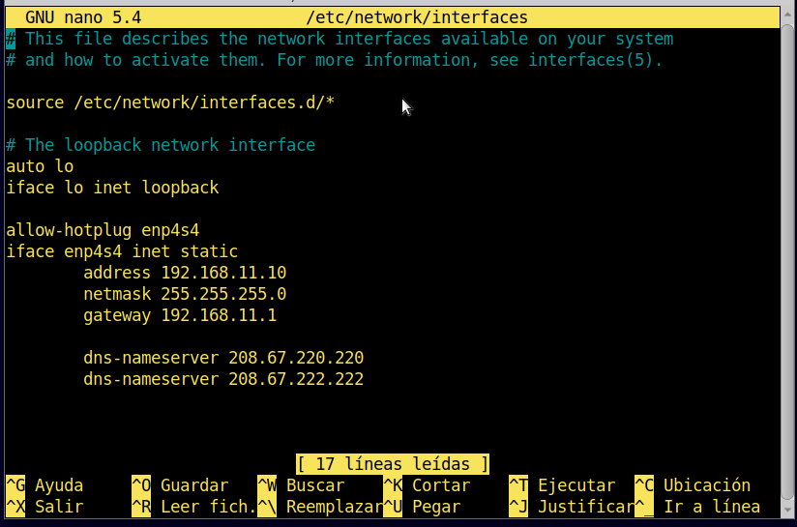
# This file describes the network interfaces available on your system
# and how to activate them. For more information, see interfaces(5).

enp2s0
source /etc/network/interfaces.d/*

# The loopback network interface
auto lo
iface lo inet loopback

allow-hotplug enp4s4
iface enp4s4 inet static
address 192.168.11.10
netmask 255.255.255.0
gateway 192.168.11.1

nano /etc/resolv.conf

nameserver 208.67.220.220
nameserver 208.67.222.222

reboot

nano /etc/apache2/ports.conf

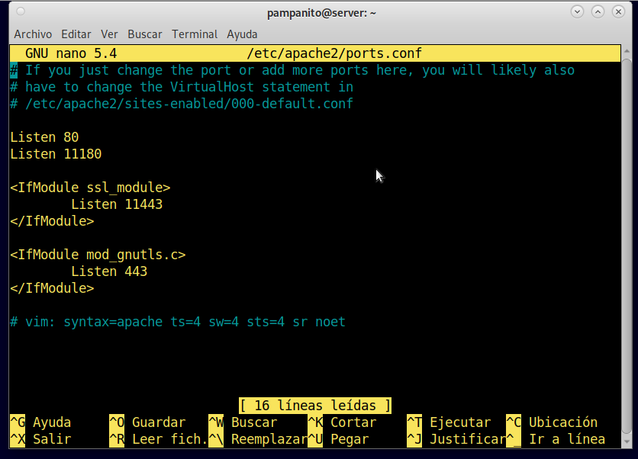
# If you just change the port or add more ports here, you will likely also
# have to change the VirtualHost statement in
# /etc/apache2/sites-enabled/000-default.conf

Listen 80
Listen 11180

<IfModule ssl_module>
Listen 11443
</IfModule>

<IfModule mod_gnutls.c>
Listen 443
</IfModule>

# vim: syntax=apache ts=4 sw=4 sts=4 sr noet

nano /etc/ssh/sshd_config
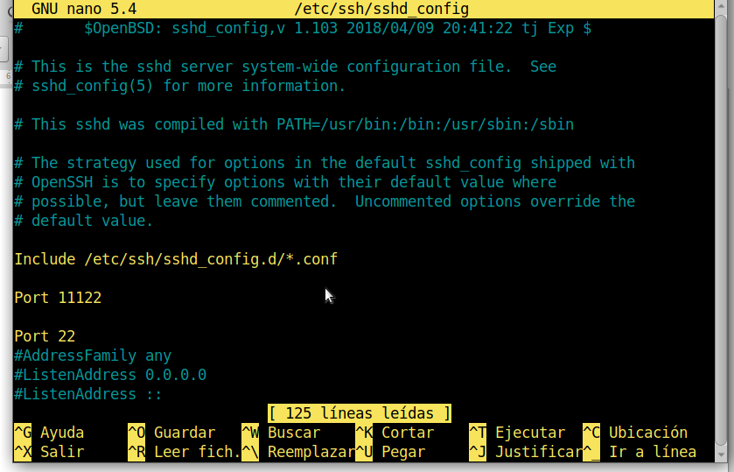
# $OpenBSD: sshd_config,v 1.103 2018/04/09 20:41:22 tj Exp $

# This is the sshd server system-wide configuration file. See
# sshd_config(5) for more information.

# This sshd was compiled with PATH=/usr/bin:/bin:/usr/sbin:/sbin

# The strategy used for options in the default sshd_config shipped with
# OpenSSH is to specify options with their default value where
# possible, but leave them commented. Uncommented options override the
# default value.

Include /etc/ssh/sshd_config.d/*.conf

Port 11122

Port 22
#AddressFamily any
#ListenAddress 0.0.0.0
#ListenAddress ::

